SMART OUTING MANAGEMENT

A project report submitted for final year of

**Bachelor of Technology**

in

**Computer Science and Engineering**

By

K PRUTHVI SAI (N140426)

M ANITHA (N140229)

R MANIKANTA SWAMY (N140249)

*Under the Supervision of*

**Mr KK Singh**



**Department of Computer Science and Engineering**

**Rajiv Gandhi University of Knowledge Technologies – Nuzvid, Krishna – 521202**

JUL 19 - APR 20



**RAJIV GANDHI UNIVERSITY OF KNOWLEDGE TECHNOLOGIES**

**(A.P. Government Act 18 of 2008)**

**RGUKT-NUZVID, Krishna Dist - 521202**

Tele Fax: 08656 – 235557/235150

**-----------------------------------------------------------------------------------------------**

**CERTIFICATE OF COMPLETION**

This is to certify that the work entitled, “Smart Outing Management**”** is the bonafied work of final year students ***R.Manikanta Swamy(N140249) ,***

***M.Anitha( N140229),K.Pruthvi Sai(N140426)*** carried out under my guidance and supervision for finalyear project of **Bachelor of Technology** in the department of Computer Science and Engineering under RGUKT IIIT Nuzvid. This work is done during the academic session Jul 2019– Apr2020, under our guidance.

---------------------------- ---------------------------

**Mr KK Singn Mr Kumar Anurupam**

Project Supervisor Head of Department

Assistant Professor Dept. of CSE Assistant Professor Dept. of CSE

RGUKT IIIT Nuzvid RGUKT IIIT Nuzvid





**RAJIV GANDHI UNIVERSITY OF KNOWLEDGE TECHNOLOGIES**

**(A.P. Government Act 18 of 2008)**

**RGUKT-NUZVID, Krishna Dist - 521202**

Tele Fax : 08656 – 235557/235150

**-----------------------------------------------------------------------------------------------**

**CERTIFICATE OF EXAMINATION**

This is to certify that the work entitled, “Smart Outing Management**”** is the bonafied work of ***R.Manikanta Swamy(N140249) , M.Anitha( N140229), K.Pruthvi Sai(N140426)*** and here by accord our approval of it as a study carried out and presentedin a manner required for its acceptance in final year of **Bachelor of Technology** for which it has been submitted. This approval does not necessarily endorse or accept every statement made, opinion expressed or conclusion drawn, as a recorded in this thesis. It only signifies the acceptance of this thesis for the purpose for which it has been submitted.

|  |  |
| --- | --- |
| ---------------------------- | --------------------------- |
| **Mr KK Singh** | **Examiner** |
| Project Supervisor | Project Examiner |
| Assistant Professor Dept. of CSE | Lecturer Dept. of CSE |
| RGUKT IIIT Nuzvid | RGUKT IIIT Nuzvid |



**RAJIV GANDHI UNIVERSITY OF KNOWLEDGE TECHNOLOGIES**

**(A.P. Government Act 18 of 2008)**

**RGUKT-NUZVID, Krishna Dist - 521202**

Tele Fax : 08656 – 235557/235150

**-----------------------------------------------------------------------------------------------**

**DECLARATION**

We, ***K.Pruthvi Sai(N140426), R.Manikanta Swamy(N140249) , M.Anitha ( N140229),*** hereby declare thatthe project report entitle “**Smart Outing Management”**done under the guidance of **Mr KK Singh** is submitted for final year of **Bachelor of Technology** in **Computer Science and Engineering** the academic session Jul2019- Nov 2019 at RGUKT – Nuzvid.

We also declare that this project is a result of our own effort and has not been copied or imitated from any source. Citations from any websites are mentioned in the references.

The results embodied in this project report have not been submitted to any other university or institute for the award of any degree or diploma.

**Date: 03-07-2019** **K Pruthvi Sai [N140426]**

**Place: Nuzvid M Anitha [N140229]**

**R Manikanta Swamy[N140249]**



**RAJIV GANDHI UNIVERSITY OF KNOWLEDGE TECHNOLOGIES**

**(A.P. Government Act 18 of 2008)**

**RGUKT-NUZVID, Krishna Dist - 521202**

Tele Fax : 08656 – 235557/235150

**-----------------------------------------------------------------------------------------------**

**ACKNOWLEDGEMENT**

#### The success in this project would not have been possible but for the timely help and guidance rendered by many people. We wish to express my sincere thanks to all those who has assisted me in one way or the other for the completion of my project.

#### We thank to my project guide Mr KK Singh, Assistant Professor Department of Computer Science and Systems Engineering for guiding me all through the project works, giving a right direction and shape to my learning by extending his expertise and experience in the education. Really I’m indebted for his excellent and enlightened guidance.

#### It is my privilege to express deepest gratitude to Mr Kumar Anurupam, Head of the Department, for his valuable suggestions and constant motivation that greatly helped the project to successfully complete.

#### We thank Prof. Surya Chandra Rao, Director of RGUKT, for his support and to all the teaching, non-teaching staff of the Department of CSE who gave all possible help to bring project work to the present shape.

#### We thank all who contributed directly or indirectly in successfully carrying out this work.

K.Pruthvi Sai

M Anitha

R Manikanta Swamy

**ABSTRACT**

During the tenure of our 6 years at this wonderful college campus we have gone for outing and on leave, on numerous occasions. We have sometimes experienced some issues while entering the gate viz. the entry of students is sometimes not marked properly, and students going outing, more number of times than the permitted in a month by using others ID Numbers(by doing so they may feel a thrilling experience but it is not a right practice).

Administration has provided us much more support and facilities than we deserve. Now, we want to help our college administration to strengthen themselves with their rules and with our idea of smart outing management. We want to establish a much stronger version of our present OLMS (Online Leave Management System). With the knowledge which we gained at this institution, we intend to help our administration and want to pay back to our lovely college.

It uses face recognition to identify the students and rectifies manual error and malpractices committed by students to go outside without the permission of the administration. It is a strong portal which provides both the functionalities effectively.

**Table of** **CONTENTS Page No**

**1 Introduction …………….…….........…..………………………………..8**

1.1 Problem outline …………………………...……8

1.2 Aims and deliverables ……………………………..….8

1.3 Main Features And Highlights ……………………………..….8

**2 Requirements ……………………………………………………………..9**

2.2 Hardware Requirements ………………………….……..9

2.3 Software Requirements …..………………………….…9

2.4 Technologies .………………………………..9

**3 Project design .……………………………………………………………..10**

3.1 Flow chart ..……………………………...10

**4 Implementation ………………………………………………………………11**

4.1 Data Collection .………………………………..11

4.2 Training the Images ………………………………….11

4.3 Basic Idea on Comparison of the Image .……………………………..…11

4.4 Portal for Leaves/Outings and Usage .……………………………..…12

**6 Future Work ……………………………….………………………...…22**

**7 Future Work ……………………………….………………………...…22**

**8 Conclusion ……………………………….………………………...…23**

**9 Reference ..………………………………………………………...…23**

**Introduction**

During the tenure of our 6 years at this wonderful college campus we have gone for outing and on leave, on numerous occasions. We have sometimes experienced some issues while entering the gate viz. the entry of students is sometimes not marked properly, and students going outing, more number of times than the permitted in a month by using others ID Numbers(by doing so they may feel a thrilling experience but it is not a right practice).

This project is all about picking those flaws and mending them and presents it in a beautiful manner which could be very useful to the university in the coming year onwards.

**Problem Outline:**

Recognizing students based on their face and reduce the manual error and stopping the malpractices done by students to go outing using ID’s of other students.

**Aims and deliverables:**

The main agenda of this project is to reduce the manual error while entering the college and provide a strong portal which cannot be manipulated by students and give a smart and advance version of OLMS.

## Main features and highlights:

* Facial Recognition
* Easily accessible
* Reduces manual error.
* Strong Portal.

.

## Requirements

**Hardware requirements:**

1. System processor: I3 or more

2. OS: Windows or Linux

3. Bus: 32 bit or 64 bit

4. Ram: 4GB or more

5. Hard disk: 500GB

**Software requirements:**

1. Any Python Editor
2. CMD(For installation of packages and running the server.)

**Technologies**:

1. Python
2. OpenCV
3. Django
4. Face Recognition

**Flow Chart**

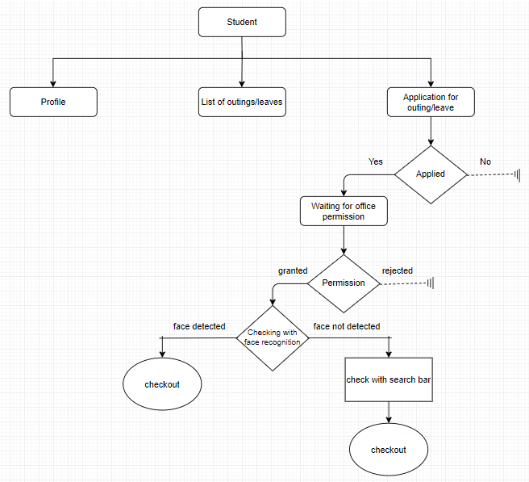

**Implementation**

**Data Collection**

First off all we have to gather all images of the students (Manually download each image of the students from the SMS site.) and label each images with respective ID number of the student and then run a program which trains and get the encoding of the images which we have gathered.

**Training the Images**

To train the images which includes mainly three steps (which are achieved using a very useful package in python i.e., face-recognition ) :

1. Loading the image
2. Detecting the face of the image and storing the face as an image.
3. Encode the face image and store it in a dictionary with ID number as key and encodings as value.

We should not do this process again and again for every comparison with unknown image hence we perform this algorithm always prior to the actual run. We store these encodings in a dictionary as I mention earlier. But the problem here is that the program should be in the same directory so we run and store all the encoding entries in a pickle file (It is handy package in which we can store huge number of datasets in less memory and accessing it back is very easy).

**Basic Idea on Comparison of the Image**

As we have all the encoding and we can compare each known encoding with the captured (unknown image) image encoding and get to know the matched image from the image directory. This module will be used in the portal to grant permission to go outside or get inside the campus only to the permitted person that is the person applied leave or outing and have status as approved in the portal.

**Portal for Leaves/Outings and Usage**

The portal we are building is from the scratch and we have used python based framework named Django which is a popular web framework. We can say that the website consists of mainly three parts which are nothing but the three various which play key role in the website and those are:

**Common Screens:**

**Registration**

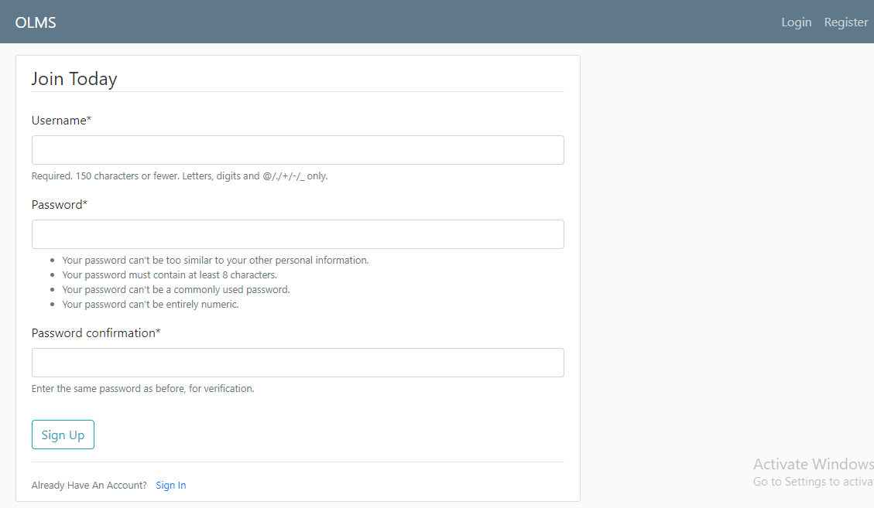

**Login**

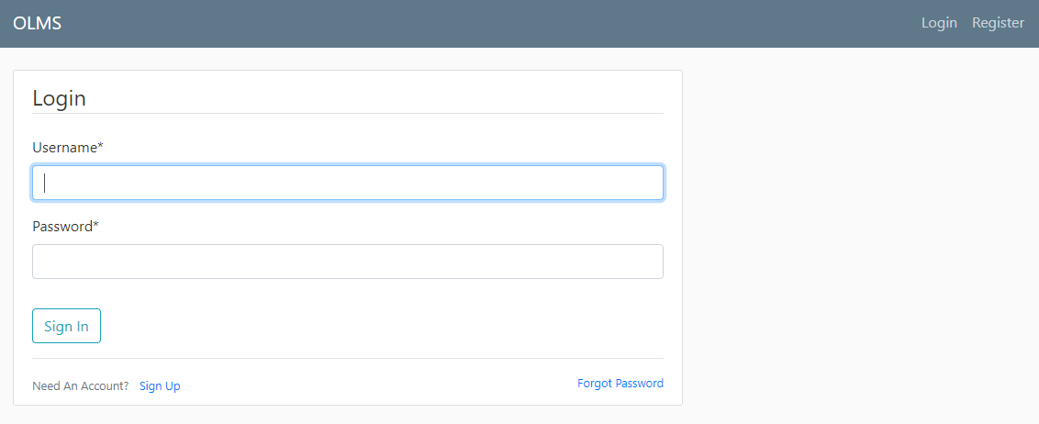

**Profile**

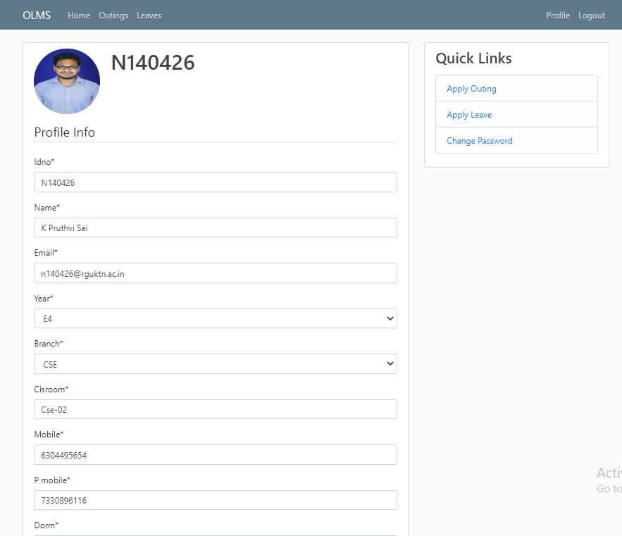

**Forgot Password**

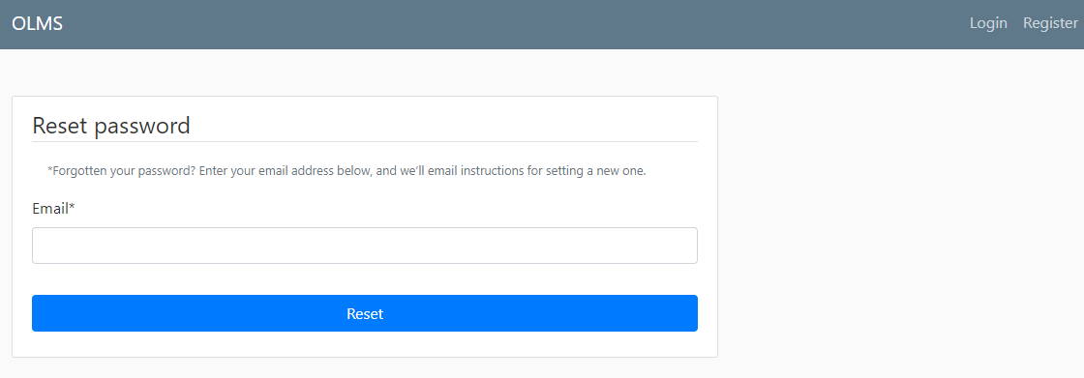

**Change Password**

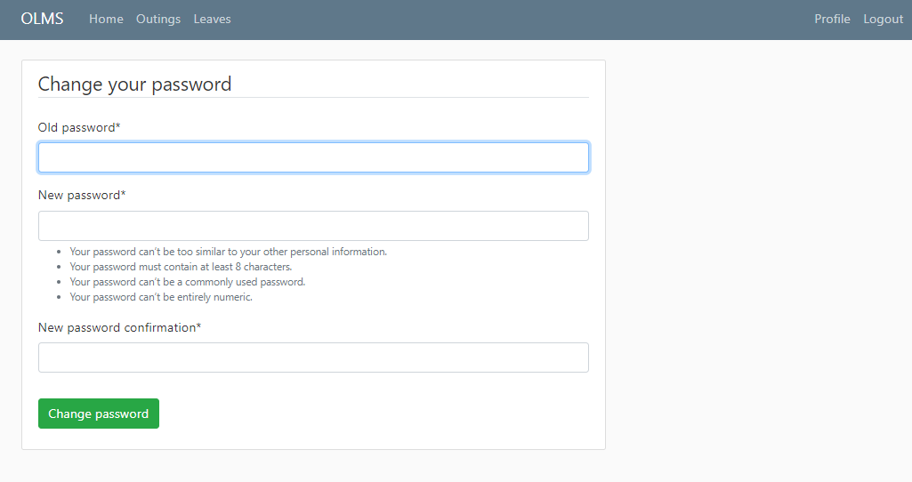

The Homepage have the two various users for login into respective accounts and admin have a different page:

1. **Student**

The Student has a login for applying outings and leaves whenever he likes. A registration process and after the registration process student use the ID no and password for login into his/her account he need to fill in the details. Student can view there various leave/outing and can apply for leave/outing and check status weather their request is granted or not.

**Student Flow Diagram**

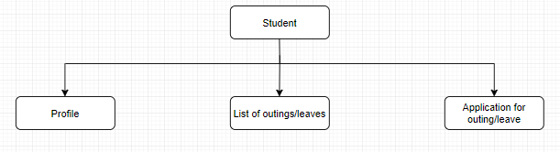

**Outing Form**

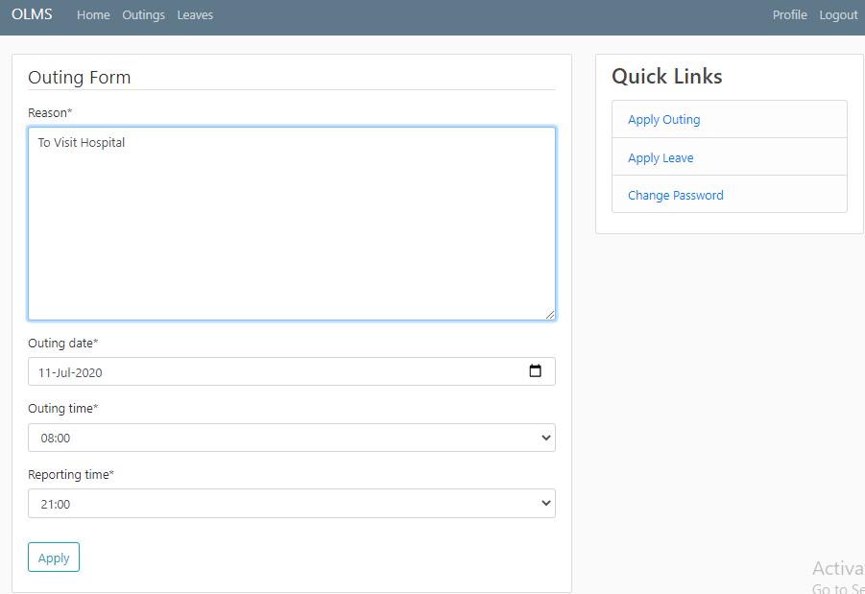

**Outing List**

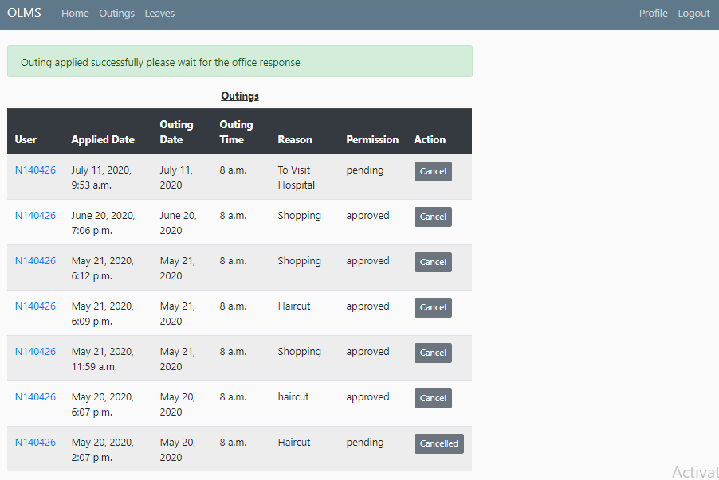

**Leave Form**

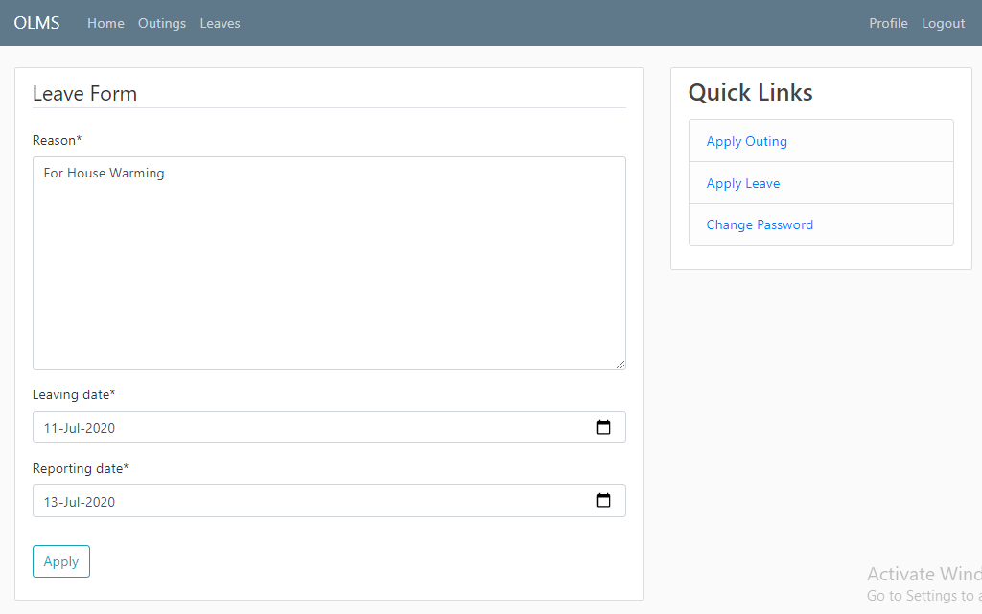

**Leave List**

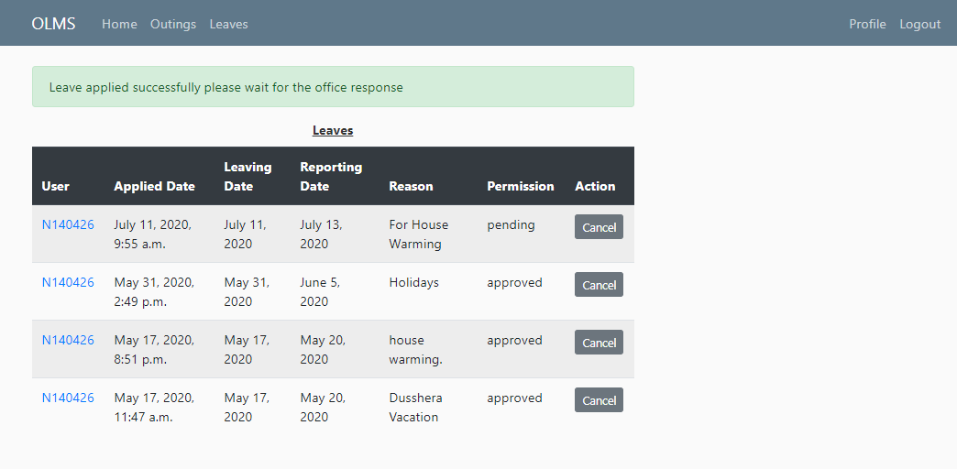

1. **Admin**

Admin will have different login credentials which will directly take him to the Django admin page where he can grant permission to students and he have filters to view pending grants first, to view already grated requests etc.

**Admin Flow Diagram**

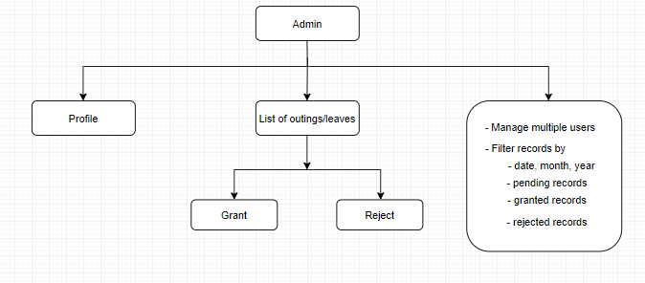

**Admin Login**

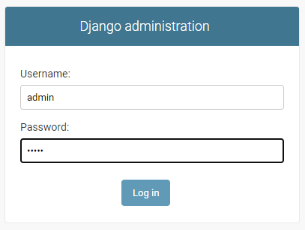

**Admin Main Screen**

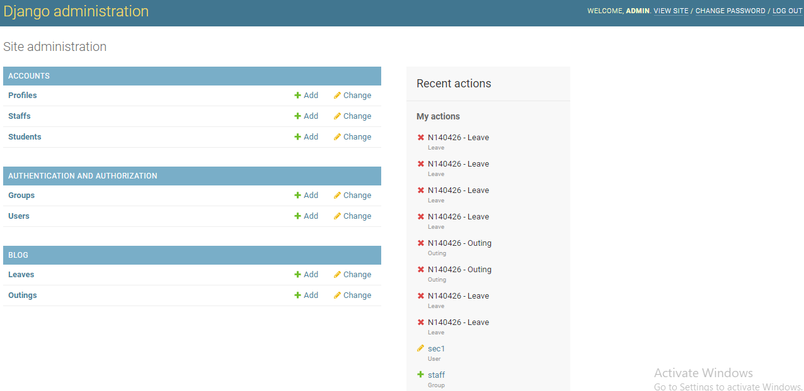

**Student List to be granted (Leave)**

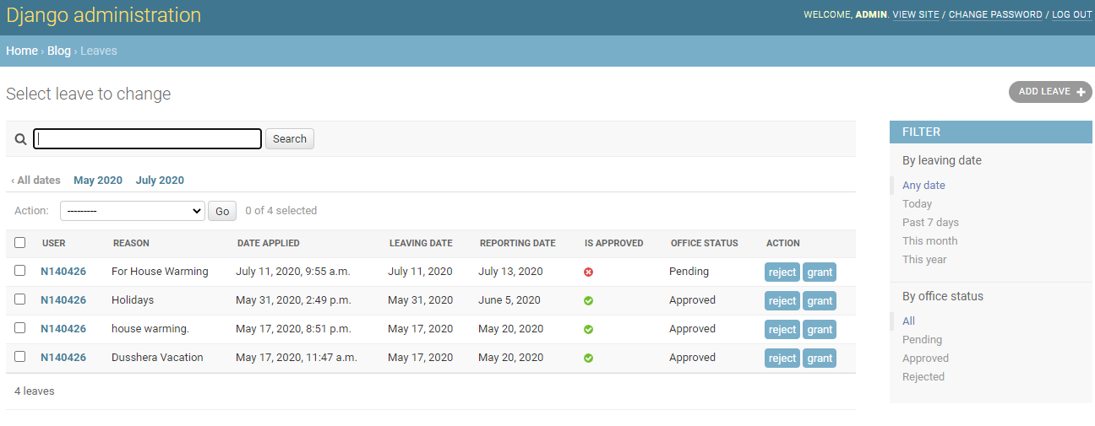

**Student List to be granted (Outing)**

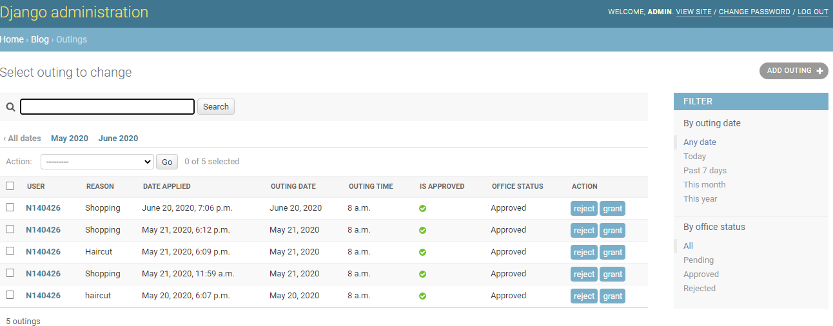

1. **Security**

Security will have same page for their login but will have different page for registration. In this portal they have the list for permitted students for outing and also have the list of students who are out of campus with permission. Here the face recognition module will be present.

Student needs to stand have captured their face in the prompt window by doing so the face comparison is performed with students who are permitted and his ID number will be fetched with two image one captured in the camera and another image which are in the known images. If the face matches with any of the images who are permitted to go outside then the two images and a field with his/her ID number and a button would appear at the screen to the security who on matching it for more reliable decision would confirm the student and send him in/out of campus.

But sometimes there may be any issues in with camera or any other mechanism so we have also put a search field which on telling the ID will fetch the image, ID number field along with grant permission button which on clicking will permit the student for leave/outing.

**Security Flow Diagram**

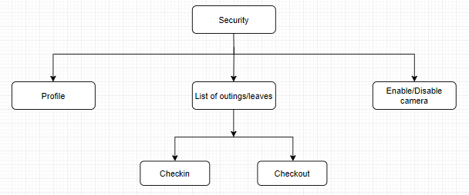

**Capture**

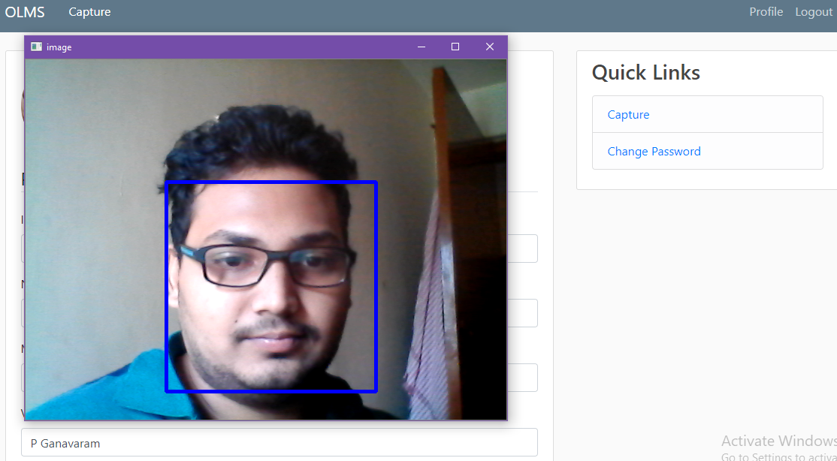

**Successful Capture While Check out**

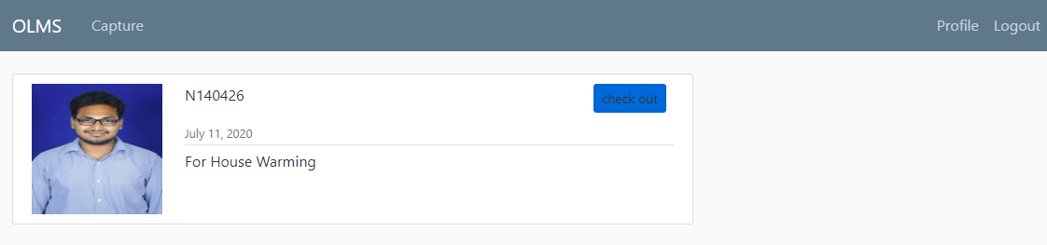

**Successful Capture While Check in**

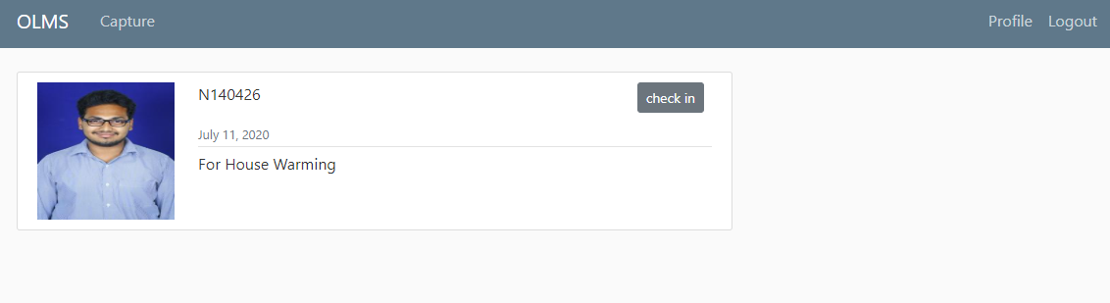

**Person Not in Granted List**

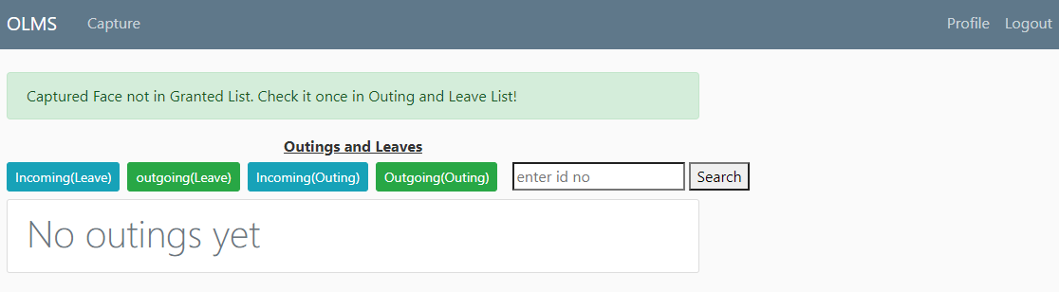

**Unsuccessful Capture**

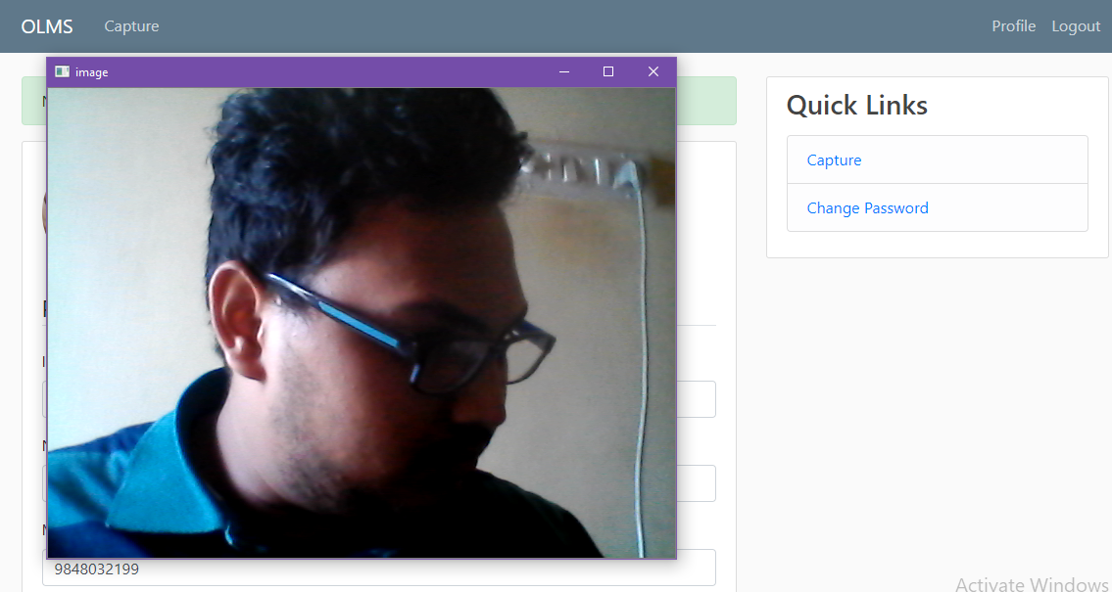

**No Face Detected**

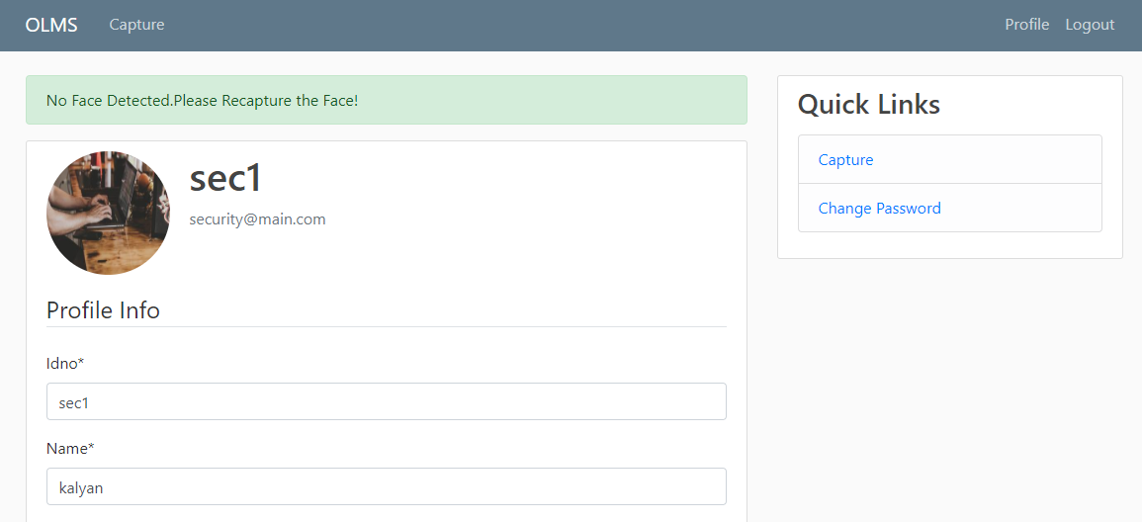

**Future Work**

* There is always a need for look and feel of a website.
* To look after the website from any software breaches in future and adapt the site according to the technology in the future.

**Further Scope of Project**

* Make the login for every member through face recognition (But still password protection is always a better option).

**Conclusion**

We have built a very efficient Web Portal for OLMS using face recognition and Django which provides the solution to the loopholes in the current version of OLMS mentioned in the report.

It not only reduces manual errors but also solves the issue of data manipulations caused by students for extra outing.

**References**

* Django Documentation
* Face-recognition Module Documentation
* OpenCV Documentation
* Google
* Stackoverflow
* Youtube